**Logical Database Design**

**Conversion of ER to Relational Model**

**Converting Strong Entity Types**

1. Each entity type becomes a relation/table.
2. Each **simple attribute** becomes a column.
3. **Derived attributes** are ignored.
4. **Composite attributes** are represented by sub components only.
5. One **primary key** is chosen from the given key attributes. It is underlined in the schema.
6. **Multivalued attributes** are represented by a separate table along with the primary key of the strong entity.
   1. The primary key for the new table will be composite primary key i.e. multivalued attribute + foreign key

**Converting Weak Entity Types**

1. Weak entity types are converted into a table of their own, with the primary key of the strong entity acting as a foreign key in the table.
2. This foreign key along with the partial key of weak entity form the composite primary key of this table.

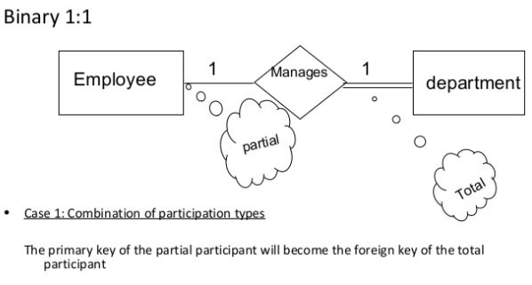

If there is total or partial on both sides of relationship then the fk can be made on any side.

**BINARY 1:N**

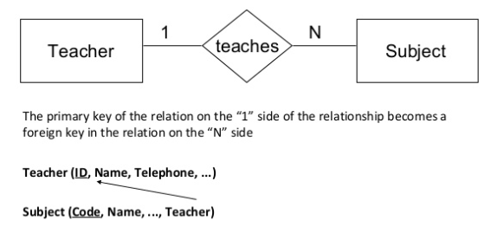

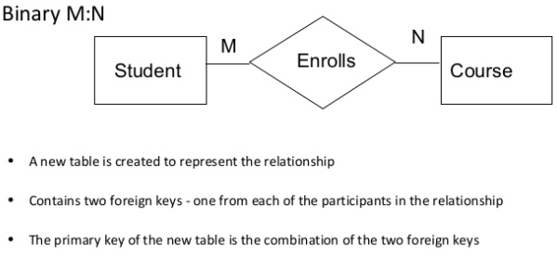

**TERNARY RELATIONSHIP**

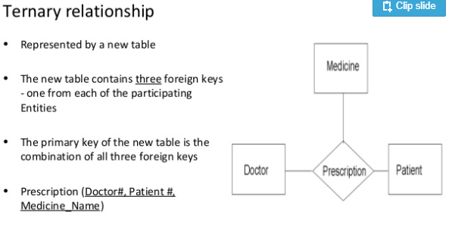

* Attributes of relationship will be made where foreign key is being made.
* For Generalization and specialization follow the same steps. Include as foreign key in the subclass the primary key of super class. Make it primary key in the subclass.